The Art of Ryan Spiritas
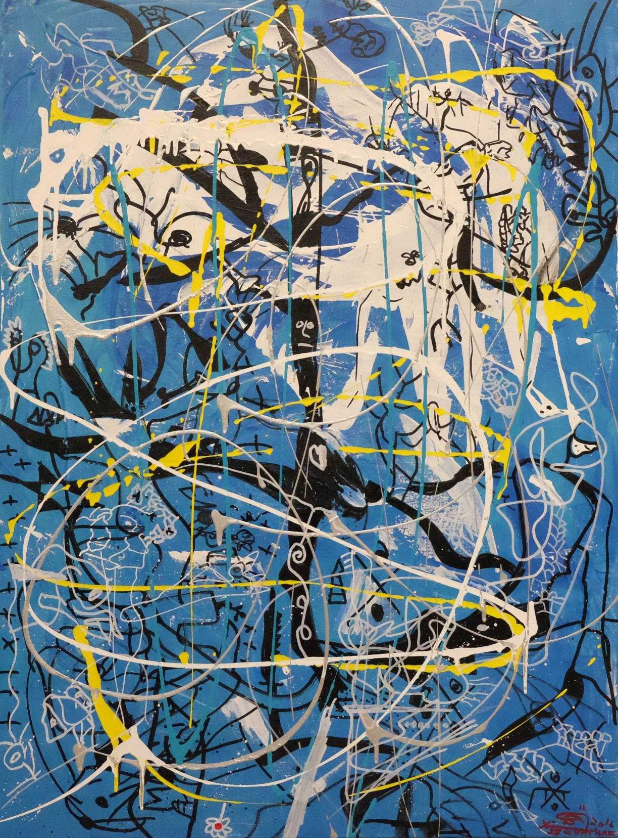
Artwork: Blue Lenin (40” x 29.5”), 2016 - Ryan Spiritas
Artist Bio: Ryan Spiritas
Emotional. Captivating. Engaging. These are just a few words used to describe the artwork of Ryan Spiritas. The Dallas native is relatively new to the contemporary art scene, but in a brief period of time has amassed a dedicated collector base which normally takes an artist decades to build.
As an Artist, Spiritas is the new normal; an emerging standard by which the art world has no specific description, no baseline for which to describe an emerging technique. His unique and whimsical style has been compared to that of Willem de Kooning, Jean DeBuffet, Jean-Michel Basquiat, Joan Miró, and Jackson Pollack. His work can best be summarized as Evocative, and as one gallerist has commented “Spiritas’ work is compelling, drawing one into his web of color and thought”.
Spiritas is a modern contemporary expressionist whose artistic style emotes a refreshing, yet twisted, portrayal of the 21st-century avant-garde through an exploitation of color. Many of his works are like views through a cacophonous lens of dysfunction that exists in his subconscious mind. As such, his pieces reflect the accumulated memories and experiences that have lingered in his head for many years with no way to escape. Spiritas, who describes himself as “strangely productive” strives to promote an irrational juxtaposition of imaginatively drawn images that direct the viewer into the world of daydreaming, yet contrast with random dark deliberations that still give a lighthearted feel to his creations.
“Creating art is a consoling and soothing factor in my life,” says Spiritas. “I like being the one against the canvas or piece of paper and I like drawing faces and things that have meaning in my life. Hopefully my art will mean something to somebody someday.”

In a conscious effort, Spiritas wants art enthusiasts to view his work before they see an image of him so their thoughts and perspectives are created solely through the art alone and free from judgement. He will unveil himself to the public during his Fort Worth exhibition on July 15th and 16th. Until then, all is left up to the imagination!
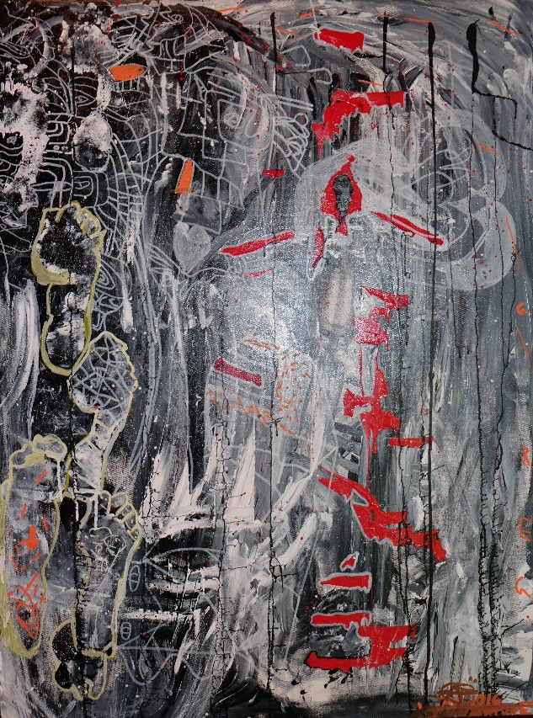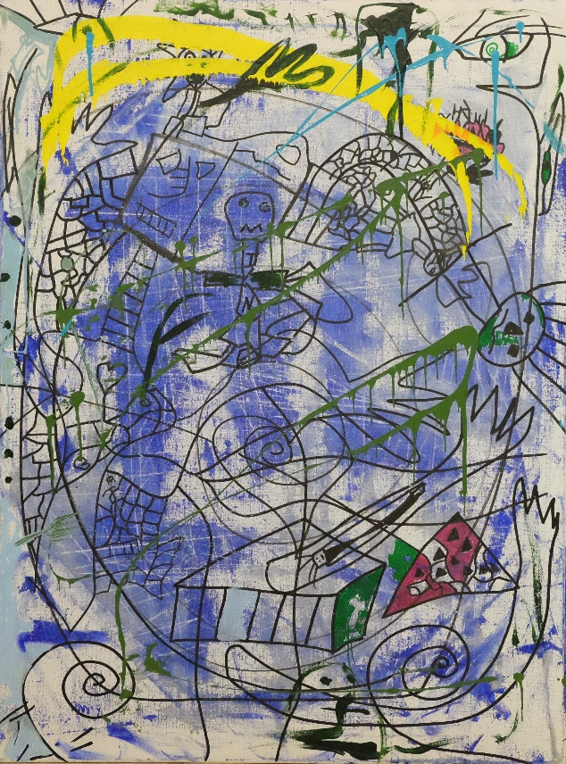
Artwork: Afghan Whigs (40” x 30”), Aftermath (30” x 40”), Ryan Spiritas - 2016
Spiritas does not have formal art training. The techniques he uses to draw and paint continue to be self-developed through inspiration, not imitation. His inspiration: the poet Shel Silverstein, the band The Residents and his super-hero artist James Surls.
Inspired by world-renowned artists Gerhard Richter and Jean-Michel Basquiat, Spiritas says of himself. “I am awkwardly different, but smart. I sometimes surprise people with my abilities and sense of humor.”

Whether drawing or painting, Spiritas naturally gets lost in the non-literal purpose of art. This allows him to explore areas of form and color not easily categorized or articulated as he displays fateful odd thoughts that are incongruous and yet harmonious, capturing contemporary life which surrounds much like a kaleidoscope in reverse.
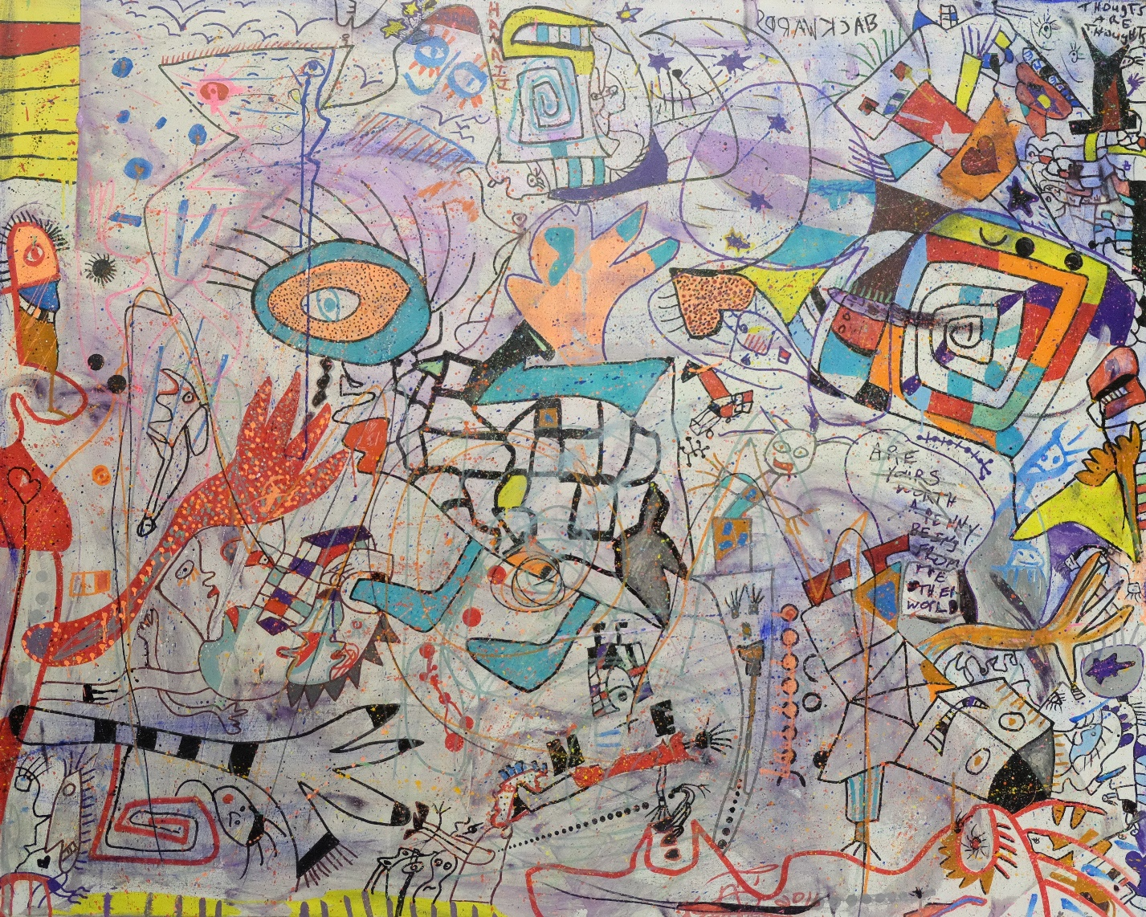
Artwork: Penny Thoughts (48” x 60”), Ryan Spiritas - 2016
ARTIST’S STATEMENT
Art, to me, is an extension of music. Both exude vast amounts of creativity, originality and depth. Music is the inspiration for everything I do in my life and in my art. When I listen to music, I feel transported into another universe where I am free to express myself without judgement and create works that depict the world around me.
I don’t have any formal training and I believe that is the reason I am able to create. Many times artists limit themselves to boundaries set forth by others and by society. I say, “Screw the boundaries”, let’s see what happens when we venture outside the realm of possibilities and the walls built to constrain us.
When I first apply paint to my brush, I let my imagination take over. I don’t control the art. The art controls me. I let the brush direct my hand. Whatever happens, happens. Just like in music, ‘mistakes’, or shall we call it, fluidity, can turn into captivating moments which last for eternity.
I am a fun, loving, quirky and some may call me, strange individual. But then again, everybody is strange in their own way. We just have to learn to embrace each other’s uniqueness. I believe my uniqueness comes through in my art. If we were all created to think, act, look and love the same way, the world would be a very boring place.
MUSICAL INFLUENCES
The National, The Residents, Flaming Lips, Band of Horses, Built to Spill, The Grates, The Black Lips, Afghan Whigs, Greg Dulli, Radiohead, Andra Day, Florence + Machine, Smashing Pumpkins, Robert Jonson, Patsy Cline and John Frusciante.
ARTISTIC INFLUENCES
James Surls, Jean Michelle Basquiat, Jackson Pollock, Gerhard Richter
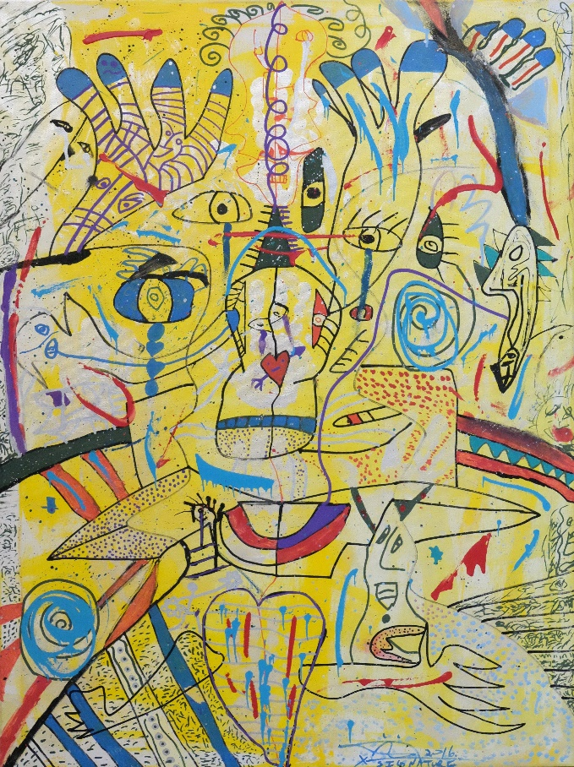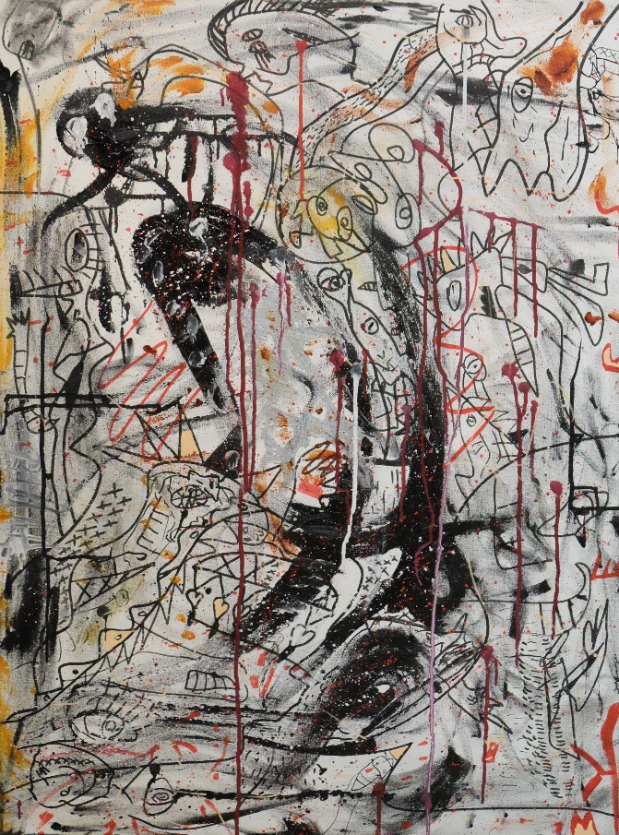
Artwork: Gold Hands (40” x 30”), Cranes (40” x 30”), Ryan Spiritas – 2016
Media Contact: Allison Zucker-Perelman - Relevant Communications allison@relevantcommunications.net or 561-715-9525

